[PPJP-9] Checking what happens when pressing on the BOOK tab Created: 21/Aug/24 Updated: 21/Aug/24
Status: | To Do
Project: | Paws Paradise-Jira project


Type: | Bug | Priority: | Medium
Reporter: | Tomer Darmon | Assignee: | Unassigned
Environment: | Google Chrome  Version 124.0.6367.202 (Official version) (64 bit)  Microsoft Edge  Version 124.0.2478.97 (Official build) (64-bit)

Attachments: | 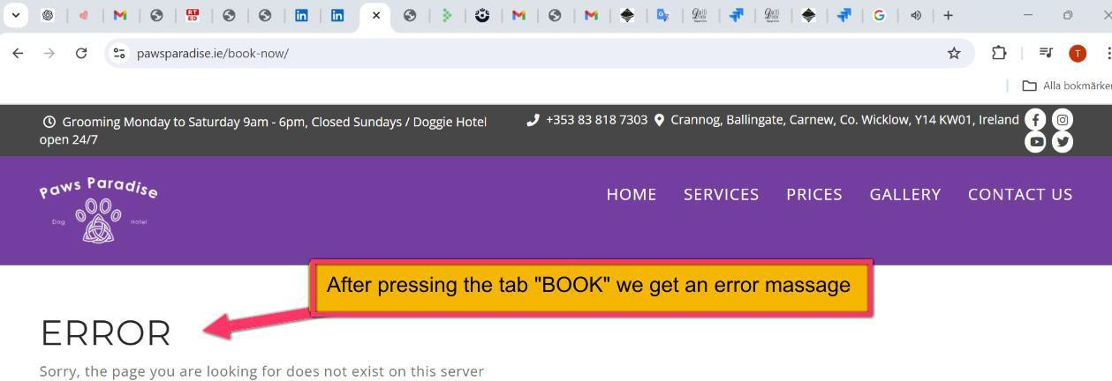
Severity1: | S3-Major

Description

Steps to Reproduce :
- Enter the website: https://www.pawsparadise.ie/
- Press on the BOOK icon and see what will happen
Actual Result :
After pressing the tab “BOOK” we get a new page but with error message
Expected Result :
I expect clicking the BOOK icon will direct me to a booking page for services

28

